Fairground Discount Beverages

Reference Manual

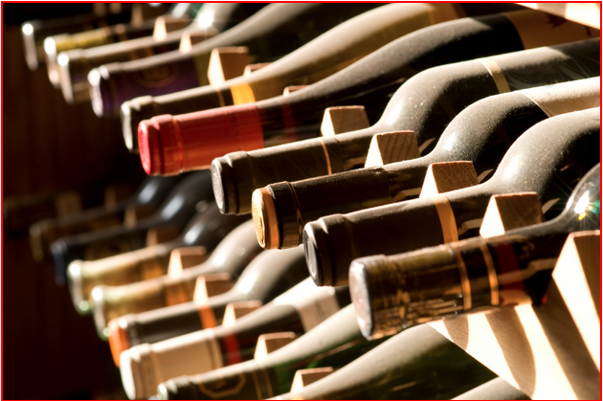

By: Richard Bell

James Miller

Nahom Negash  
 Derrick Witherspoon

**Table of Contents**

1. **Inventory – common operation** ……………………………………………………… 3
   1. Item search……………………………………………………………………………. 3
   2. New Item Entry…………………………………………………………………....... 4
   3. Edit Item……………………………………………………………………………...... 6
   4. Delete Item……………………………………………………………………………. 7
2. **Sale Details – common operation** …………………………………………………... 9
   1. Sale Item Search……………………………………………………………………... 9
   2. Add New Sale ……………………………………………………………………….. 10
   3. Edit Sale ……………………………………………………………………………….. 11
   4. Delete Entry…………………………………………………………………………..13
3. **Staff Details – common operation** …………………………………………………. 14
   1. Staff Search…………………………………………………………………………... 14
   2. New Staff Entry…………………………………………………………………….. 15
   3. Edit Staff/Entry…………………………………………………………………….. 16
   4. Delete Staff ………………………………………………………………………….... 18
4. Inventory – Common Operation

This section is intended to give administration of Fairgrounds Discount Beverage a detailed step-by-step instruction for how to use Inventory on Fairground Discount Beverage database system.

* 1. Searching Item

There are two ways to search for an item:

1. Type in the item you are searching for in the **Item Search** at the home page.

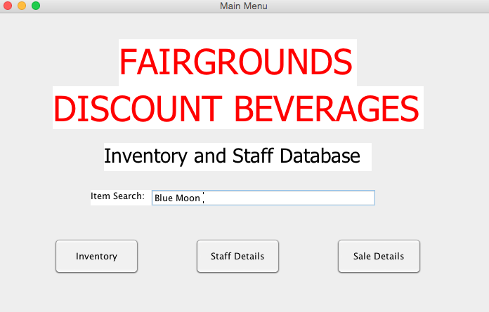

OR,

1. Select **Inventory** on bottom left

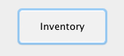

1. On the top right corner place in the item you are searching for in the

**Item Search** box.

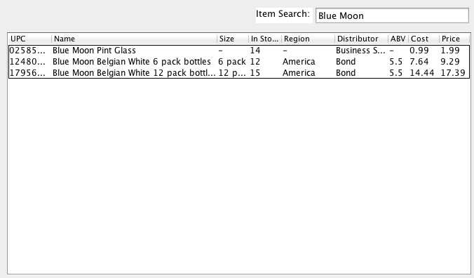

* 1. Adding New Item

1. Select **Inventory** from the home screen.



1. Click on **New Entry** on bottom left of Inventory page

Macintosh HD:Users:Nahom:Desktop:Screen Shot 2014-12-07 at 6.47.12 AM.png

1. Enter in an item with the following information:
   1. Name
   2. UPC
   3. Size
   4. Available (quantity)
   5. ABV (only for alcohols)
   6. Region
   7. Distributor
   8. Cost
   9. Price
   10. Department number
   11. Department Name

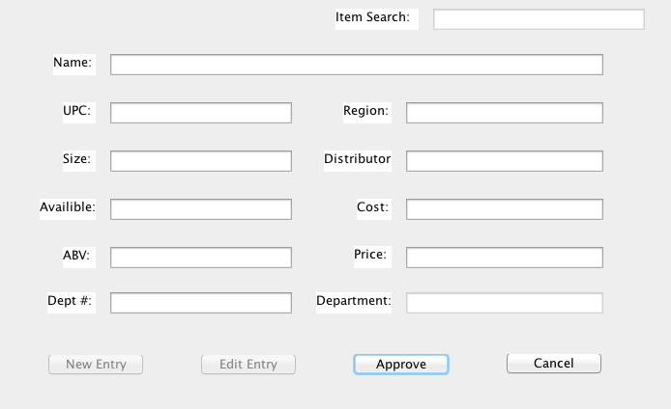

1. Click **Approve** to confirm your entry.

Macintosh HD:Users:Nahom:Desktop:Screen Shot 2014-12-07 at 7.30.43 PM.png

* 1. Edit Item Entry

You can edit an existing item in the database

1. Select **Inventory** from the home screen



1. Top right corner search for the item you wish to edit in the **Item**

**Search**

Macintosh HD:Users:Nahom:Desktop:Screen Shot 2014-12-07 at 7.24.23 AM.png

1. Click the item and **Edit** the following information:
   1. Name
   2. UPC
   3. Size
   4. Available
   5. ABV
   6. Region
   7. Distributor
   8. Cost
   9. Price
   10. Department number
   11. Department information

Macintosh HD:Users:Nahom:Desktop:Screen Shot 2014-12-07 at 7.36.33 PM.png

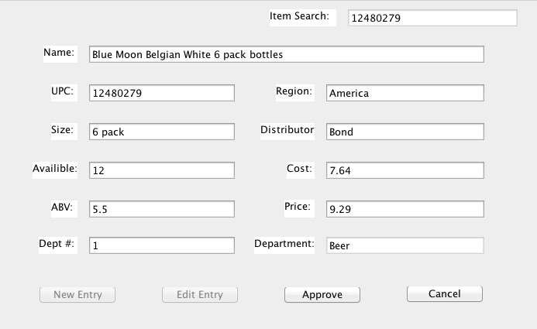

1. Click Approve once completed

Macintosh HD:Users:Nahom:Desktop:Screen Shot 2014-12-07 at 7.30.43 PM.png

* 1. Delete an Entry

1. Select **Inventory** from the home screen



1. Type item in **Item Search** box

Macintosh HD:Users:Nahom:Desktop:Screen Shot 2014-12-07 at 7.24.23 AM.png

1. Click **Delete Entry** bottom right

Macintosh HD:Users:Nahom:Desktop:Screen Shot 2014-12-07 at 7.41.42 PM.png

1. Select **Yes** or **No**

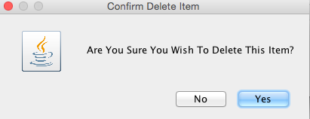

1. Click **Approve** to update the database

Macintosh HD:Users:Nahom:Desktop:Screen Shot 2014-12-07 at 7.30.43 PM.png

1. Sale Details – Common Operation

This section is intended to give administrators of Fairground Discount Beverage a step-by-step instruction on how to manage a sale using the database.

______________________________________________________________________________________________

* 1. Searching for Items that are on sale

1. Select **Sale Details** from the home screen

Macintosh HD:Users:Nahom:Desktop:Screen Shot 2014-12-07 at 7.44.36 AM.png

1. If the item is on sale, it will show on the list

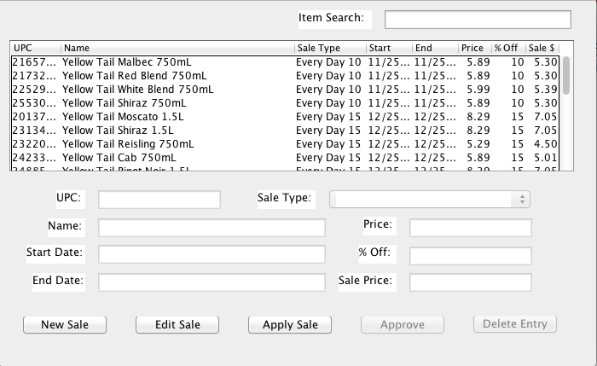

1. If not, to verify, search the item in the **Item Search** box on the top right corner

Macintosh HD:Users:Nahom:Desktop:Screen Shot 2014-12-07 at 7.55.25 AM.png

* 1. To add new Sale

1. Select **Sale Details** from the home screen

Macintosh HD:Users:Nahom:Desktop:Screen Shot 2014-12-07 at 7.44.36 AM.png

1. Click on **New Sale** on bottom left

Macintosh HD:Users:Nahom:Desktop:Screen Shot 2014-12-07 at 8.02.35 AM.png

1. Enter new sale with the following information
   1. Start Date
   2. End Date
   3. %Off (percent off)

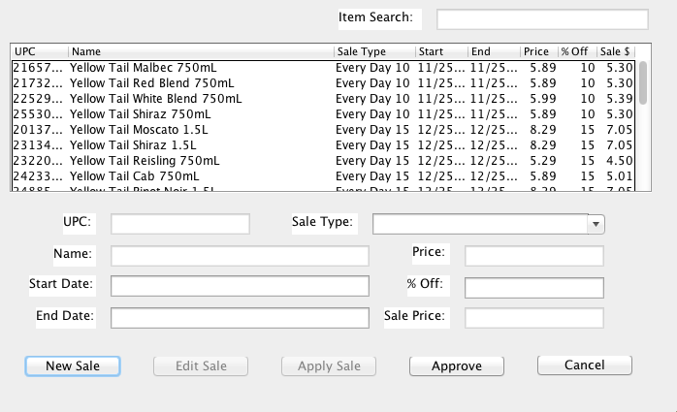

1. Click on **Approve** to submit the new sale information

Macintosh HD:Users:Nahom:Desktop:Screen Shot 2014-12-07 at 9.04.01 PM.png

1. Select **Yes** or **No** to confirm

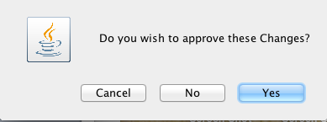

1. Press **Cancel** button to cancel the sale

Macintosh HD:Users:Nahom:Desktop:Screen Shot 2014-12-07 at 8.19.23 AM.png

* 1. Editing existing sale

1. Select **Sale Details** from the main screen

Macintosh HD:Users:Nahom:Desktop:Screen Shot 2014-12-07 at 7.44.36 AM.png

1. Choose which **Sale Type** you want to edit

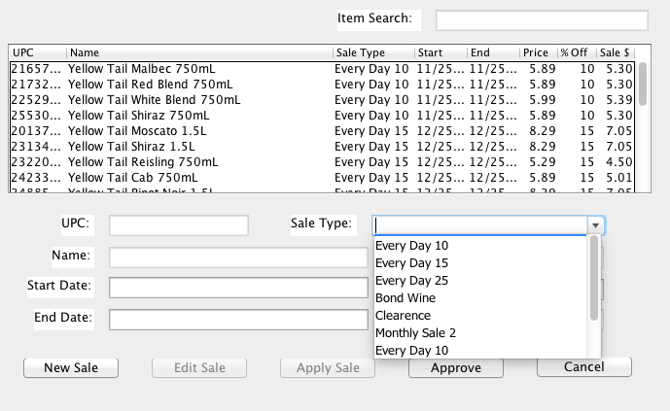

1. Update the sale with the following information:
   1. Start Date
   2. End Date
   3. % off (percent)

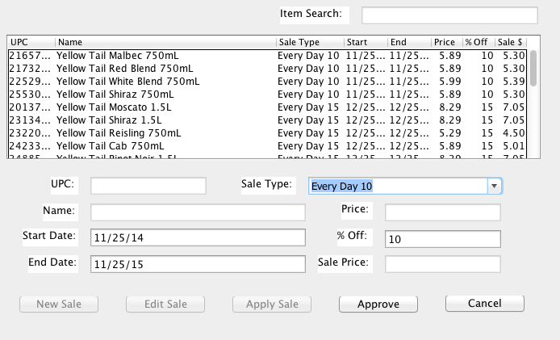

1. When finished, press **Approve** button

Macintosh HD:Users:Nahom:Desktop:Screen Shot 2014-12-07 at 9.04.01 PM.png

* 1. Deleting existing sale

1. Select **Sale Details** from home screen

Macintosh HD:Users:Nahom:Desktop:Screen Shot 2014-12-07 at 7.44.36 AM.png

1. Select the item that needs to be deleted

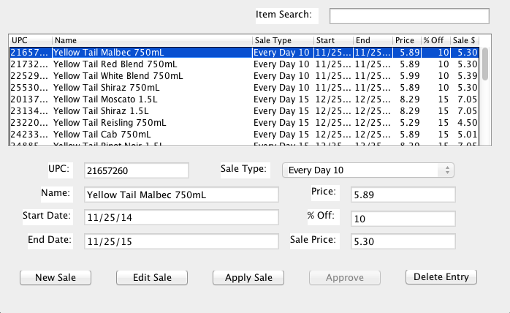

1. Press the **Delete Entry** Button

Macintosh HD:Users:Nahom:Desktop:Screen Shot 2014-12-07 at 10.15.08 PM.png

1. Staff Details– Common Operation

This section is intended to give administrators of Fairground Discount Beverage a step-by-step instruction on how to manage staff management using the database.

__________________________________________________________

* 1. Searching Staff Information on file

1. Select **Staff Details** from home screen

Macintosh HD:Users:Nahom:Desktop:Screen Shot 2014-12-07 at 9.08.51 AM.png

1. Place staff member name in **Staff Search** box in the top right corner.

Macintosh HD:Users:Nahom:Desktop:Screen Shot 2014-12-07 at 9.12.45 AM.png

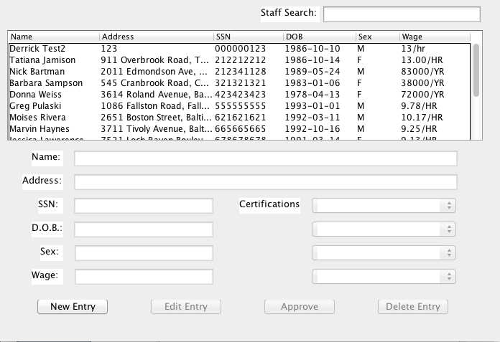

* 1. Entering new Staff information

1. Select **Staff Details** from the home screen

Macintosh HD:Users:Nahom:Desktop:Screen Shot 2014-12-07 at 9.08.51 AM.png

1. Click on **New Entry** on the bottom left corner

Macintosh HD:Users:Nahom:Desktop:Screen Shot 2014-12-07 at 9.25.33 AM.png

1. Enter new staff with the following information:
   1. Name
   2. Address
   3. SSN
   4. D.O.B
   5. Sex
   6. Wage
   7. Certifications (if any)

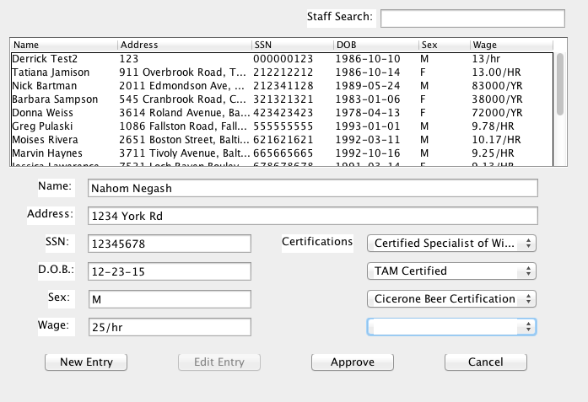

1. Click **Approve** to confirm the request

Macintosh HD:Users:Nahom:Desktop:Screen Shot 2014-12-07 at 10.22.08 PM.png

1. Select **Yes**, **No** or **Cancel** to confirm

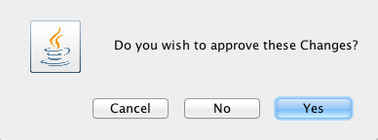

1. Click **Cancel** to cancel the process

Macintosh HD:Users:Nahom:Desktop:Screen Shot 2014-12-07 at 8.19.23 AM.png

* 1. Editing existing staff information

1. Select **Staff Details** from home screen

Macintosh HD:Users:Nahom:Desktop:Screen Shot 2014-12-07 at 9.08.51 AM.png

1. Select the Staff

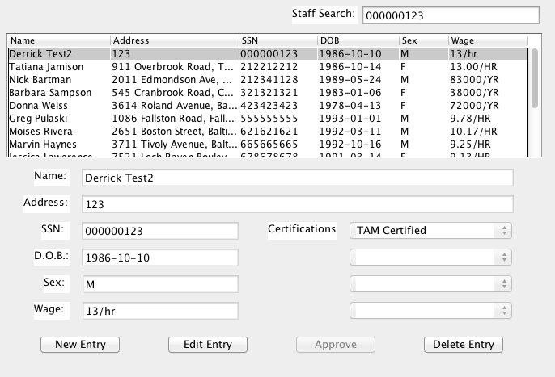

1. Click **Edit** button

Macintosh HD:Users:Nahom:Desktop:Screen Shot 2014-12-07 at 10.31.09 PM.png

1. Update the staff information using the following:
   1. Name
   2. Address SSN
   3. D.O.B.
   4. Sex
   5. Wage
   6. Certifications
2. Click on **Approve** to finish the request

Macintosh HD:Users:Nahom:Desktop:Screen Shot 2014-12-07 at 10.22.08 PM.png

* 1. Delete Staff entry

1. Select **Staff Details** from home screen

Macintosh HD:Users:Nahom:Desktop:Screen Shot 2014-12-07 at 9.08.51 AM.png

1. Select the Staff



1. Click **Delete Entry** on bottom right corner to delete

Macintosh HD:Users:Nahom:Desktop:Screen Shot 2014-12-07 at 10.33.30 PM.png

1. Click on **Approve** button to finalize the request

Macintosh HD:Users:Nahom:Desktop:Screen Shot 2014-12-07 at 10.22.08 PM.png